Individual Assignment 2

- (30 Pts) Busiest North American Airports. Based on the total passenger traffic, the
airports in the file Airports from Chapter 5 in dataset.zip are among the busiest in North
America.
a.)
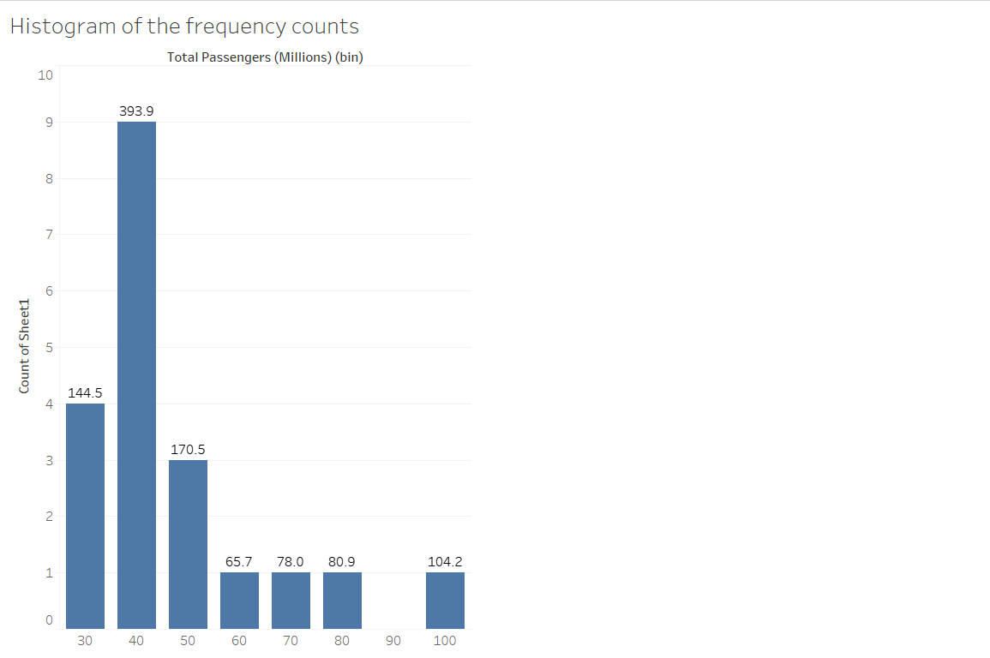

b.) The most common passenger traffic range based on this histogram is 30-40 million, as indicated by the highest bar with a frequency count of 393.9.

c.) The shape of the histogram is skewed to the right, meaning there are a few bins with high frequency counts and many with lower counts.

2. (40 pts) Missing Data for Product Satisfaction Rating. To understand the implications
of missing data, we must explore the patterns associated the missing entries for the
Product Satisfaction Rating variable in the EJB from Chapter 6 in dataset.zip.

a.)
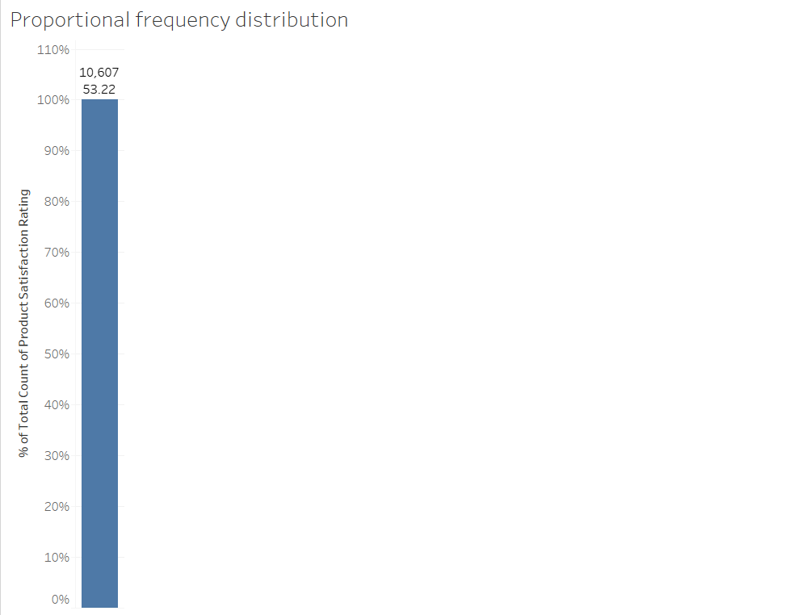

The proportion of records lacking a Product Satisfaction Rating value is...
The proportion of records where the Product Satisfaction Rating value is absent is 53.2186%.

b.)

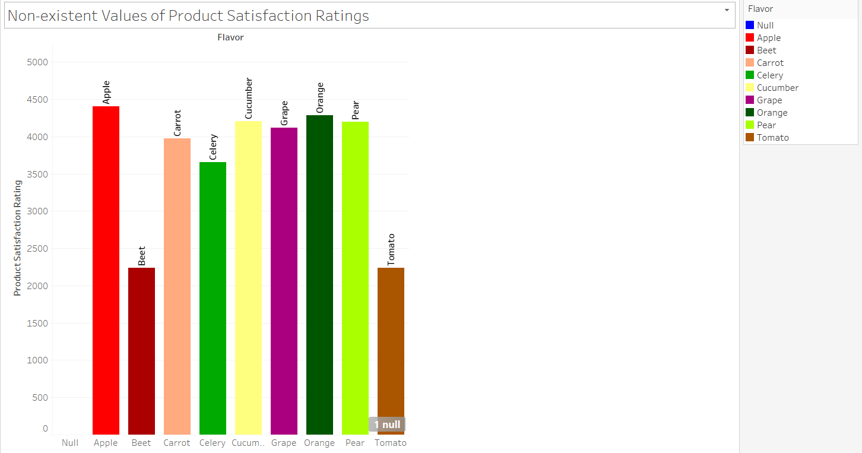

C.)
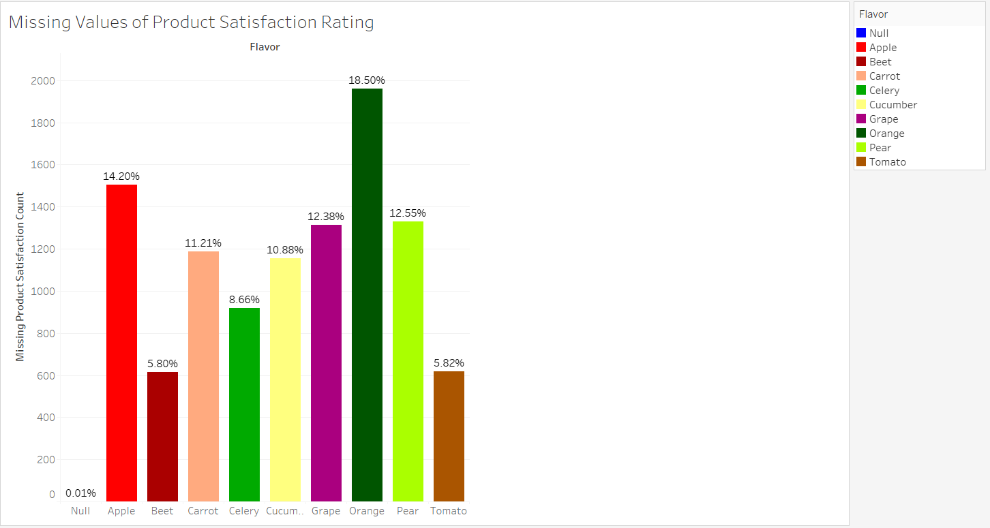

d.)
Counts in Variability:
- The range of values in part b, which counts the non-missing values, is 2235 to 4408 for each flavor, whereas part c, which counts the missing values, spans from 1 to 1962. This validates a significant gap in data gathering between the two polls.
Proportion of Missing Values:
- The missing data values perices from about 5.82% to 18.50% in the Pi-chart (c). The finding may dependent on the number of missing values varying across varieties of chocolates.
- Favors i.e orange, pear and apple were the ones that are missing in high percentage. This then can be concluded as the issue with the data collection or reporting process for these two flavors.
- Orange, pear, and apple flavors had larger percentages of missing results than other flavors, which might be a sign of bias or problems during the data collecting process.
3.) (30 pts) Market Capitalization and Profit By Sector. The file Fortune500Sector in
chapter 6 contains data on the profits, market capitalizations, and industry sector for a
recent sample of firms in the Fortune500Sector from Chapter 6 in dataset.zip.
a.)

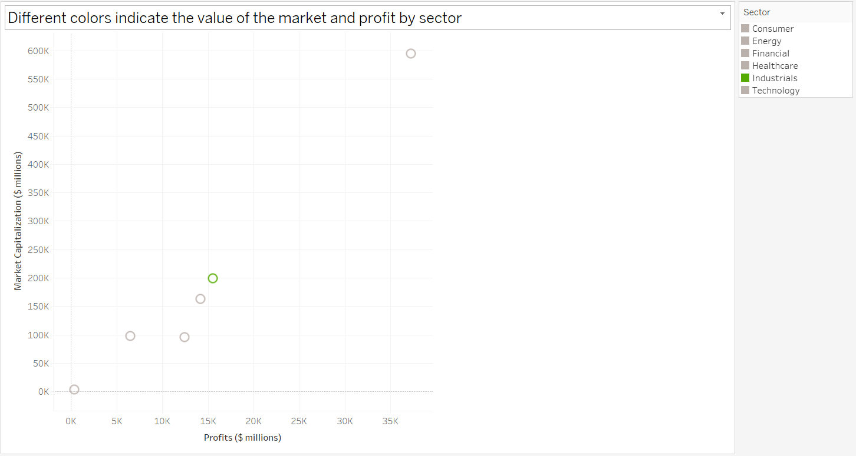

b.)
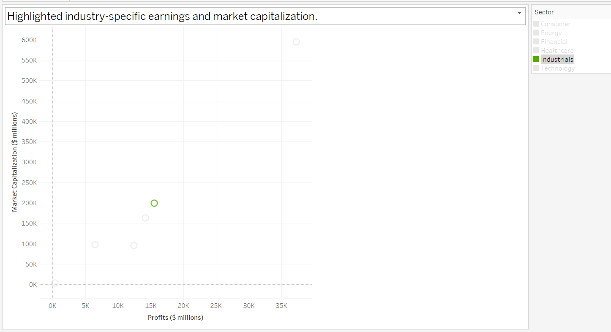

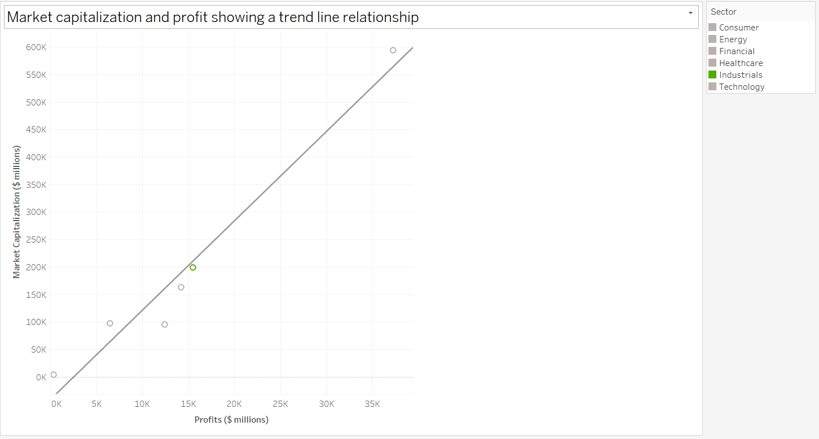

- Robust and Optimistic Relationship:
- The trendline equation indicates a positive coefficient because there is a substantial positive correlation in the Industrials sector (16.2675), indicating a strong association between Market Capitalization and Profit.
- The link between Market Capitalization and Profits indicates that the former rises and the latter does the same.

- High Precision Predictability:
- As indicated by the strong R-squared value of 0.95984, the trendline accounts for about 95.98% of the variation in Market Capitalization based on Profits within the Industrials department.
- This indicates that the trendline matches the data rather well and has a good forecast accuracy.

- Statistical Importance:
- The trendline's statistical significance is indicated by the cutting-edge p-value of 0.0006131.
- This rules out the chance that market capitalization and profit in the industrials sector have arbitrary correlations.

- Correspondence with Data:
- The trendline equation and the market capitalization and profitability data for the Industrials sector match, indicating that the observed link is consistent with the predicted trend.

- Consequences for Making Decisions:
- Investors and other stakeholders may also use this link to evaluate the financial stability and performance quality of the industrials sector's businesses.
- Companies in the sector may use this information to assess the effects of profits on their market capitalization.

C.)
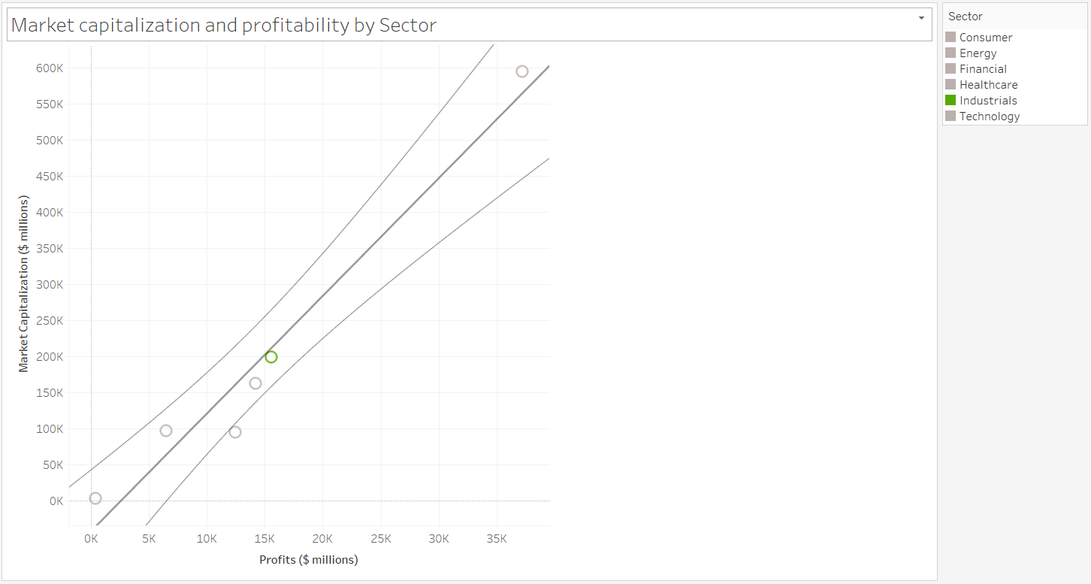

Name: Raju Rishikesh Gollapally Student Id: 811285826.

